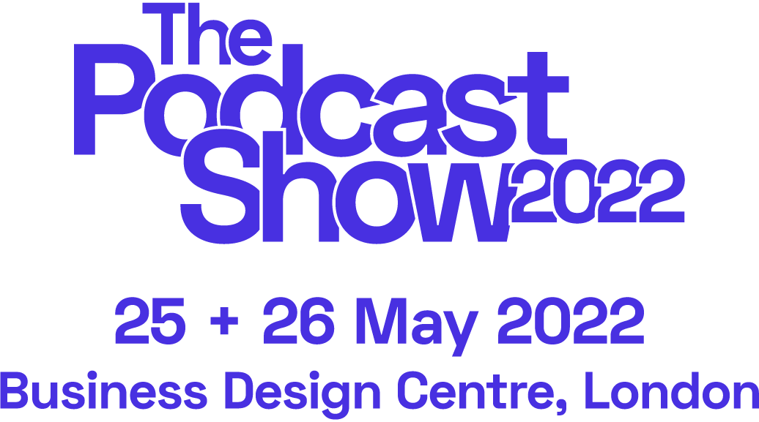

**BOILERPLATE COPY**

<LONG, 263 words>

**Join us at the New International Festival for Podcasting!**

The Podcast Show 2022 is a breakthrough podcasting festival that promises to inspire and shape the future of the sector, taking place **25-26 May** at **The Business Design Centre, London**. By day, the show will welcome industry pros, independent podcast creators, emerging talent and fans alike to **masterclasses, workshops** and over **120 global brands**. By night, The Podcast Show LIVE will take over London for **7 nights of live podcast shows** across Islington, making this the biggest festival of its kind.

The event will host **150 panels and sessions** and over **350 speakers**, including *Fearne Cotton, Ross Adams (Acast CEO), Jen Sargent (Wondery CEO), The Receipts Podcast* and inaugural guest curators, *My Dad Wrote a Porno*. Delegates can also expect unrivalled international **networking** opportunities with executives and decision makers, **masterclasses**, chances to **meet the experts**, **feedback and advice centres** through to a **creator’s corner**, networking bars, major **partner activations** and a smattering of very special guests too. The festival’s **‘Brand Works’** will be a central hub to bring brands and advertisers together with podcast creators. Expect global industry leaders, recognisable talent, and brands around every corner.

The Podcast Show LIVE will feature a week-long programme of **20 live podcast shows**. World-class talent, including **Fearne Cotton’s *Happy Place*, *Comfort Eating with Grace Dent*, *RedHanded &* Elis James and John Robins**, will be in venues across Islington, London, making this the biggest festival of its kind.

**Delegate day passes are from £55, with a limited number of tickets for those aged 30 and under. Book yours now at thepodcastshowlondon.com - limited availability.**

#PodShowLDN

<MID, 117 words>

**Join us at the New International Festival for Podcasting!**

The Podcast Show 2022 is a first-of-its-kind event for the global podcast community, running 25-26th May at The Business Design Centre, London. Tickets are strictly limited.

By day, the show will welcome industry pros, independent podcast creators and business leaders to masterclasses, workshops, pop-up stages, special guest appearances and over 120 global brands. By night, The Podcast Show LIVE will take over London for 7 nights of live podcast shows across Islington, making this the biggest festival of its kind.

**Don’t miss the podcasting event of the year! Delegate day passes are from £55, or £30 if you’re aged 30 or under. Book now at thepodcastshowlondon.com**

#PodShowLDN

<SHORT 84 words>

**Join us at the New International Festival for Podcasting!**

*The Podcast Show 2022 is a breakthrough podcasting festival*, running 25-26 May at The Business Design Centre, London.

By day, 150+ hours of thought leadership and fan programming, featuring 350+ speakers. By night, The Podcast Show LIVE will take over London for 7 nights of live podcast shows across Islington. Wherever you are on your podcasting journey - this is for you.

**Delegate day passes are from £55 and are on sale now at thepodcastshowlondon.com**

#PodShowLDN

***Socials***

Instagram: [@PodcastShowLDN](https://www.instagram.com/podcastshowldn/)

Facebook: [@PodcastShowLDN](https://www.facebook.com/PodcastShowLDN)

Twitter: [@PodcastShowLDN](https://twitter.com/podcastshowldn)

LinkedIn: [@PodcastShowLDN](https://www.linkedin.com/company/the-podcast-show/)